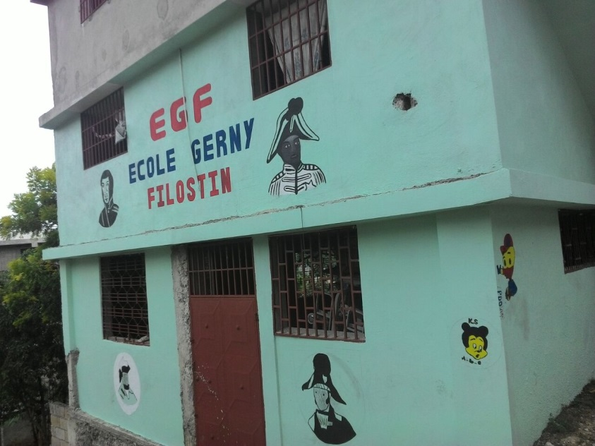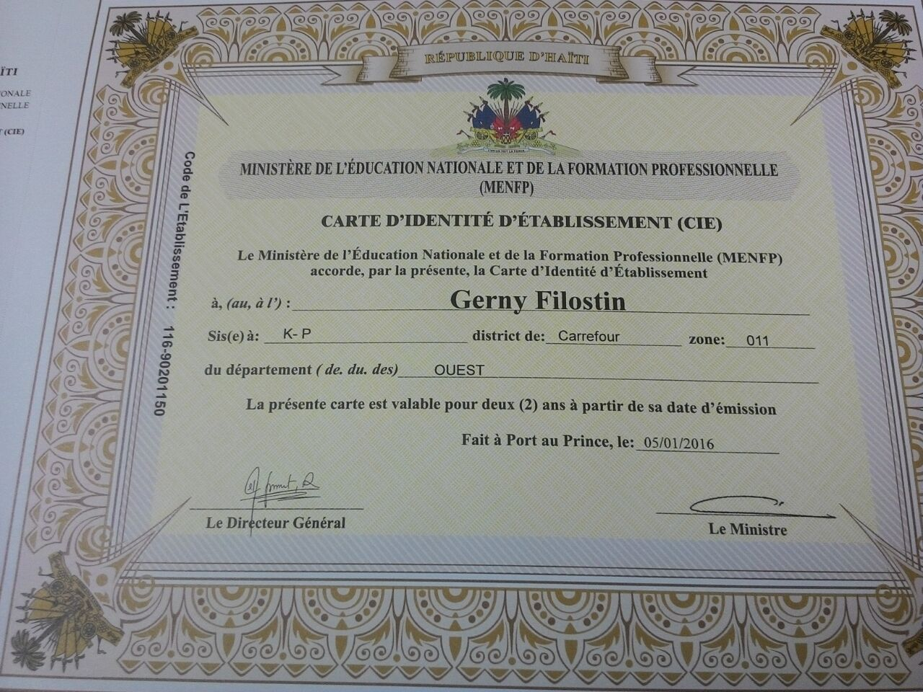
Dear Haiti Supporter,
The kids are back in school! 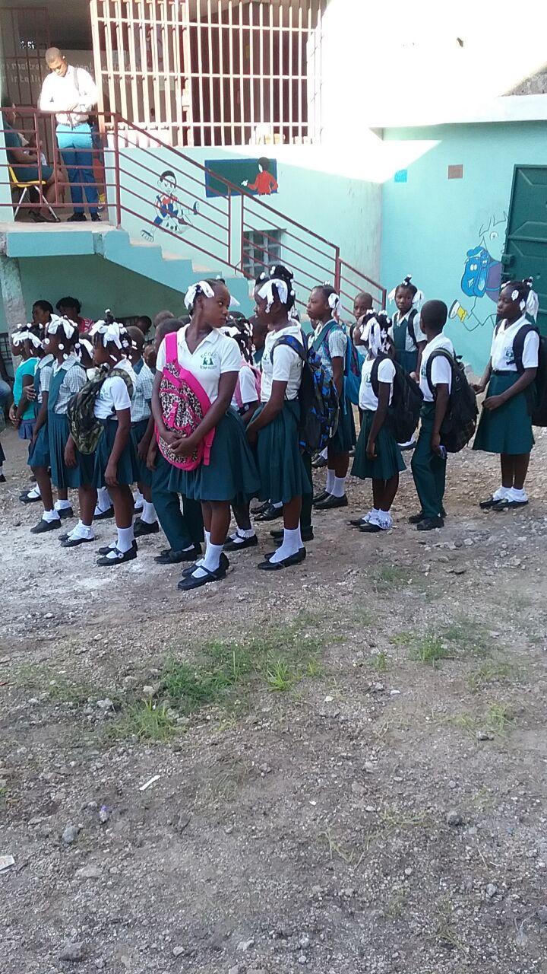Fall is here and the school has a new look as paint and iron bars in the windows have upgraded the facility. These changes have helped Ecole Gerny Filostin receiving its certificate from the Ministry of Education. Madam Roseline and her teachers and the IOG staff have worked very hard for this accomplishment!

The need for shoes and uniforms has again been an issue for many of the children as more than half of the school enrollment are street children who have little in the way of support. We are thankful for the churches that have gathered supplies and send donations to support these kids who would otherwise be wandering the streets during the school day. Our lunch program continues as well, as these children receive a nutritious hot meal each day, again thanks to the contributions of IOG supporters here in the U.S. The school opens their doors to every student they can, so the need for ongoing support is great. If you or your group would like to support a teacher or a classroom or contribute toward the daily expenses of running the school, please send your contributions to
The Institute of Grace, P.O. Box 2364, Leesburg, VA 20177
[These contributions are tax-deductible and make a world of difference.]

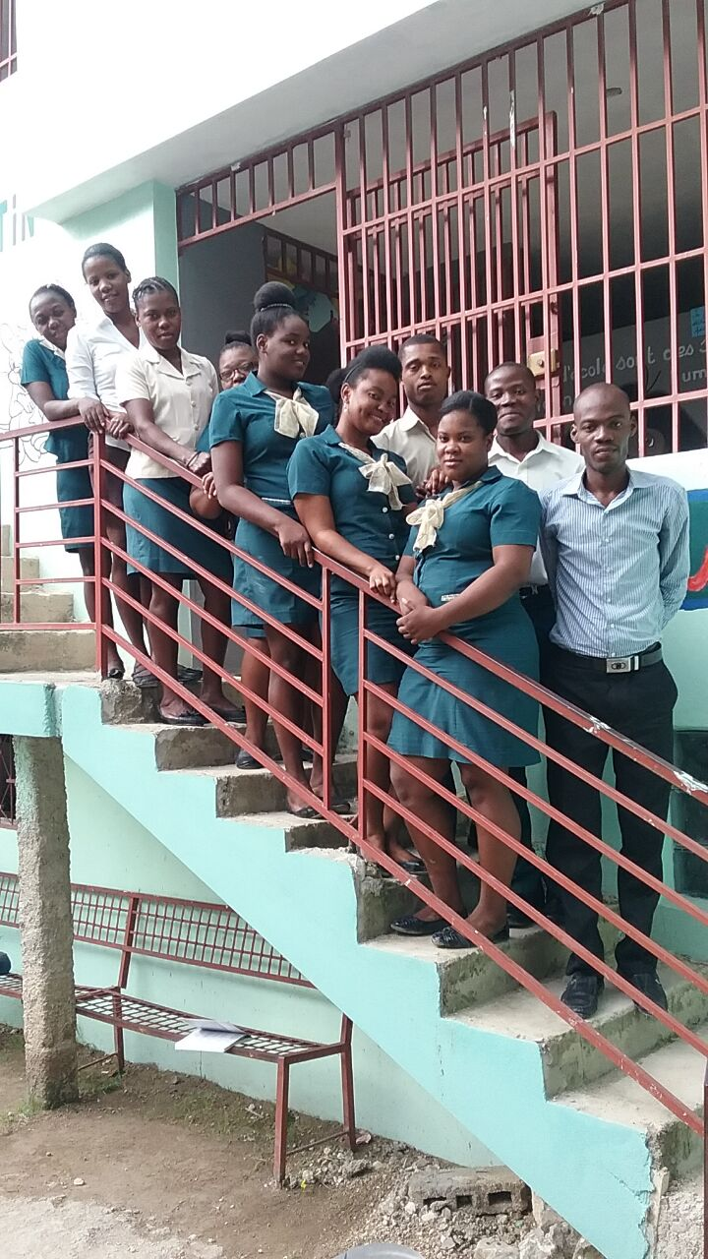
Here are ten of our dedicated teachers. At the very top left is Madam Roseline, our principal. And the barely visible head also at the top is Madam Bercy, the school administrator/secretary. The teachers have children from 3 years old up to 6th grade. The school is only able to operate with support from the US, so they appreciate your support.
Planning for teams in 2017 has begun. And one of the big impacts teams have is bringing lessons for the children and teacher development for our teachers. Team members have the opportunity to work directly with the children and also build the teaching skills that help the children all year long.
Of course, construction projects are ongoing and the pastor group continues to grow in size and impact. Give me a call or an email if you would like to be part of a team in 2017.
DavidGraves1982@gmail or 240 601 0218.

With a monthly payroll and feeding expenses exceeding $2200/month for over 100 students, the school is dependent on our donations. Thanks for being part of the ongoing mission of helping Haitians learn and grow, physically and spiritually.
David Graves for

The Institute of Grace
P. O. Box 2364
Leesburg, VA 20177
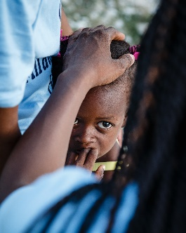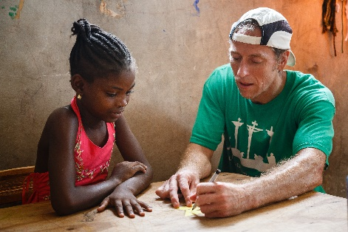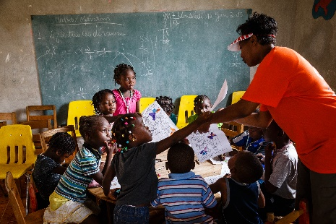
Jess T. and Yves in class

